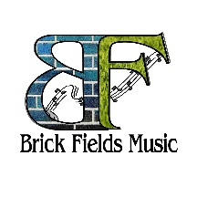
technical rider & Stage plan for duo / trio
Thank you for your interest in booking Brick Fields
Below is a list of our technical requirements for Brick Fields acoustic Duo. If there are any questions or if you have trouble providing anything, please get in touch with us prior to the show and we will work out a solution.

Lead Vocals / Rhythm guitar / flute
Rachel “Brick” Fields
Mic: Shure 58 with boom stand
1 DI for acoustic guitar and stand
1 Chair with no arms
1 small table for flute and water
Please no flashing lights, mellow slow rotating lights are good.

Larry Brick
Lead guitar / back vocals
Guitar: Amp
Acoustic Guitar DI
Mic: Shure 58 with boom stand

